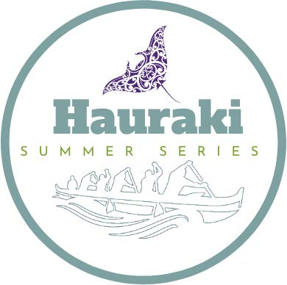
RACE 1 – 19TH FEB 2022
TE PURU,
THAMES COAST

RACE SCHEDULE
This event will be running in multiple waves, with each wave having their own dedicated wave zone for waka, registration, my vaccine pass check, safety checks etc. Please adhere to the times and specific wave zones for your race as per the information below. There will be no congregating between races or after races, please leave as soon as you have finished racing to allow the next race to arrive.
Ngā mihi whānau!

Wave 1
W1 & W2 8km – All age divisions (Men, Women)
W6 8km – J16 & J19 (Men, Women, Mixed)
Please go to Wave 1 Zone.
Rego Opens: 7am in wave 1 zone.
Race Brief: 8am in wave 1 zone.
Race Start: 8.30am

Wave 2
W6 16km – Open, Master, Senior Master & Golden Master (Men, Women, Mixed)
Please go to Wave 2 Zone.
Rego Opens: 9am in wave 2 zone.
Race Brief 10am in wave 2 zone.
Race Start: 10.30am

